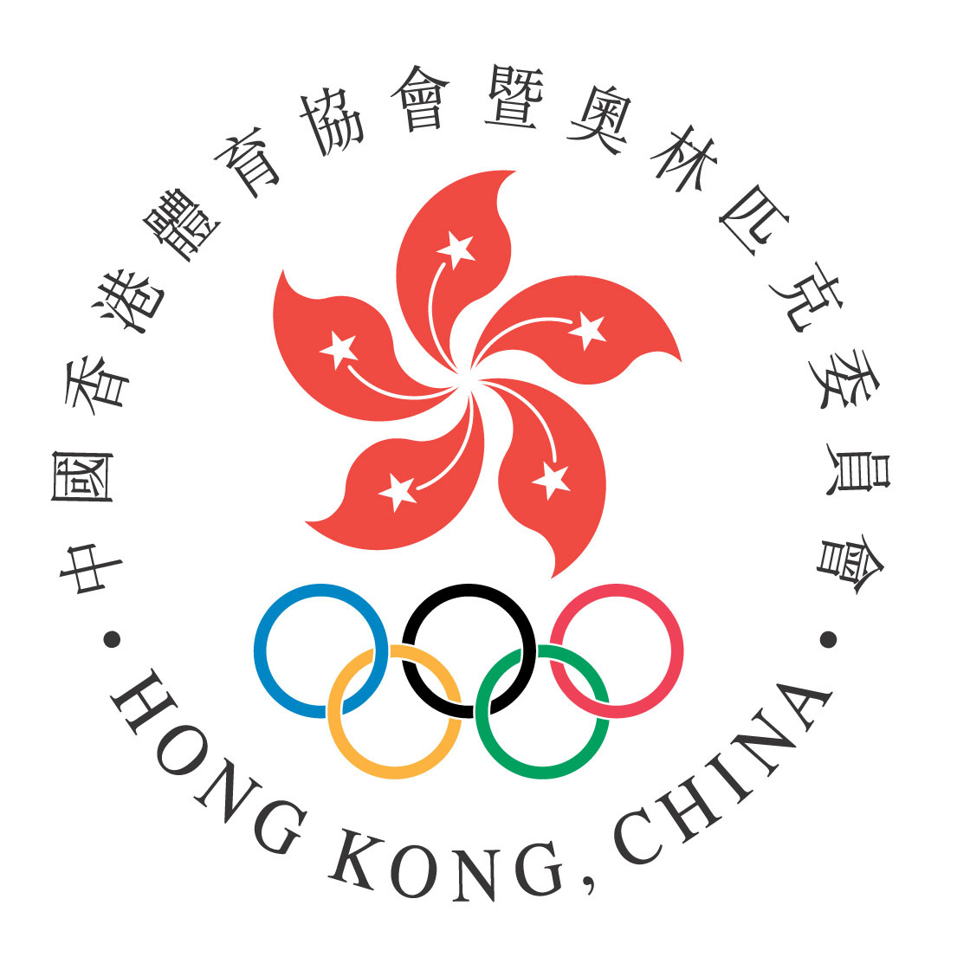
HONG KONG ANTI-DOPING COMMITTEE
香港運動禁藥委員會

Application Form
Therapeutic Use Exemptions
治療用藥豁免申請表

Please complete all sections in capital letters or typing 請以大寫或印刷體填妥所有部分
Section 1,4,6: to be completed by athlete 第 1、4、6部分：由運動員填寫
Section 2,3,5: to be completed by prescribing physician 第 2、3、5部分：由處方醫生填寫

- Athlete Information 運動員資料
Surname 姓：............................................................ Given Names 名：........................... ............... ............... ...........

Female 女性 □ Male 男性 □ Date of Birth(d/m/y) 出生日期（日／月／年）：...................................................... ....

Address 地址：.............................................................................................................................................................................

......................................................................................................................................................................................................

Tel. 電話：............................................................ E-mail 電郵： ......................................................................................

Sport 體育項目：............................................................ Discipline/Position 小項／位置：.........................................................

International or National Sport Association 所屬國際體育聯會或國家體育總會：................................................................................

Please mark the appropriate box 請於適用方格加「✓」:
- I am part of an International Federation Registered Testing Pool 我已被列入國際體育聯會的藥檢登錄名單
- I am part of Hong Kong Anti-Doping Committee Registered Testing Pool 我已被列入香港運動禁藥委員會的藥檢登錄名單
- I am participating in an International Federation event for which a TUE granted pursuant to the International Federation’s rules is required ¹ 我將會參加國際體育聯會的指定比賽，並根據國際體育聯會的規則需取得治療用藥豁免
– Name of the competition 比賽名稱: ___________________________________
- None of the above 以上全都不是

If athlete with disability, indicate disability 如果運動員殘疾，請說明殘疾情況：

......................................................................................................................................................................................................

¹ Refer to your International Federation for the list of designated events
請聯絡所屬國際體育聯會索取指定比賽的名單

- Medical information 醫療資料
Diagnosis with sufficient medical information (see note 1) 包括充分醫療資料的診斷（見註一）:
…………………………………………………………………………………………………………………………………………………………………………………………………………………………………………
…………………………………………………………………………………………………………………………………………………………………………………………………………………………………………
…………………………………………………………………………………………………………………………………………………………………………………………………………………………………………
…………………………………………………………………………………………………………………………………………………………………………………………………………………………………………
If a permitted medication can be used to treat the medical condition, provide clinical justification for the requested use of the prohibited medication 如有允許使用的藥物可用於治療，請提供必須使用所申請的禁用藥物的臨床依據
…………………………………………………………………………………………………………………………………………………………………………………………………………………………………………
…………………………………………………………………………………………………………………………………………………………………………………………………………………………………………
…………………………………………………………………………………………………………………………………………………………………………………………………………………………………………
…………………………………………………………………………………………………………………………………………………………………………………………………………………………………………

Note 1: Evidence confirming the diagnosis shall be attached and forwarded with this application. The medical evidence should include a comprehensive medical history and the results of all relevant examinations, laboratory investigations and imaging studies. Copies of the original reports or letters should be included when possible. Evidence should be as objective as possible in the clinical circumstances and in the case of non-demonstrable conditions independent supporting medical opinion will assist this application. Please also provide English/Chinese translation of the supporting document if the originals are in other languages.
註一： 明確診斷的依據，應與申請一併提交。診斷依據應包括詳盡的醫療記錄以及所有相關檢查結果、實驗室檢查、造影檢查；盡可能遞交所有報告或信件的複印本。臨床證據必須盡可能客觀，如果客觀證據不明顯，支持申請的獨立醫學意見將有助有關申請。當診斷依據原文為非中文/英文時，請提供有關文件的中文/英文翻譯。

- Medication details 藥物詳情
Prohibited substance(s) 禁用物質  Generic name 學名 | Dose 劑量 | Route 處方途徑 | Frequency 處方頻密程度
1.
2.
3.
Intended duration of treatment  預計服用時間  （Please tick appropriate box  請於適用方格加「✓」) | once only 一次 □ emergency 緊急時用 □  or duration (week/month) 或持續服用時間(周／月)： ……………………………………………

- TUE request history 要求批准治療用藥豁免紀錄
Have you submitted any previous TUE application 閣下是否曾提交批准治療用藥豁免的要求？ yes 是 □ no 否 □
If yes, for which substance? 如「是」，是為使用哪種物質？

……………………………………………………………………………………………………………………………………………………………………………………………………………
To whom 向哪個機構提交要求？ ……………………………………………………… When 何時提交？……………………………………………………

Decision 審批結果： Approved 批准 □ Not approved 否決 □

- Medical practitioner’s declaration 醫療人員聲明
I certify that the above-mentioned treatment is medically appropriate and that the use of alternative medication not on the prohibited list would be unsatisfactory for this condition.
本人保證上述治療在醫學上是合理的，而使用不在禁用清單之列的替代藥物治療此症，將得不到滿意的療效。

Name 姓名：…………………………………………………………………… Medical specialty 專科：………………………………………………………………………………
Address 地址：………………………………………………………………………………………………………………………………………………………………………………………………………………
Tel. 電話：…………………………………………………………………………………… Fax 傳真：………………………………………………………………………………………………
E-mail 電郵： ………………………………………………………………………………………………………………………………………………………………………………………………………………
Signature of Medical Practitioner 醫療人員簽署：……………………..………………………………… Date 日期：…………………………………………………………

6. Athlete’s declaration 運動員聲明
I, …………………………………………………………………………………. certify that the information under 1. is accurate and that I am requesting approval to use a Substance or Method from the WADA Prohibited List. I authorize the release of personal medical information to Hong Kong Anti-Doping Committee (HKADC) as well as to WADA authorized staff, to the WADA TUEC (Therapeutic Use Exemption Committee) and HKADC TUECs and authorized staff that may have a right to this information under the provisions of the Code.

I understand that my information will only be used for evaluating my TUE request and in the context of possible anti-doping violation investigations and procedures. I understand that if I ever wish to (1) obtain more information about the use of my information; (2) exercise my right of access and correction or (3) revoke the right of these organizations to obtain my health information, I must notify my medical practitioner and HKADC in writing of that fact. I understand and agree that it may be necessary for TUE-related information submitted prior to revoking my consent to be retained for the sole purpose of establishing a possible anti-doping rule violation, where this is required by the Code.

I understand that if I believe that my personal information is not used in conformity with this consent and the International Standard for the Protection of Privacy and Personal Information I can file a complaint to WADA or CAS.

本人…………………………………………………………………………………………，確認在’1’提供的資料準確無誤，並為了合法採用世界運動禁藥機構禁用物質而提出有關申請。本人同意依照世界運動禁藥法規，將個人醫療資料提交香港運動禁藥委員會、世界運動禁藥機構的有關職員、世界運動禁藥機構治療用藥豁免專責委員會，及香港運動禁藥委員會治療用藥豁免專責委員會的有關職員。

本人明白本人的醫療資料只會用作於評定治療用藥豁免申請和執行禁藥管制調查和程序。本人明白當本人希望(1)得知上述組織如何運用本人的資料；(2)行使查閱及更改個人資料的權力；(3)撤銷上述組織取得本人健康資料之權力，本人必須以書面方式通知本人的醫療人員和香港運動禁藥委員會。本人明白並同意根據世界運動禁藥法規本人在撤回前的醫療資料將會保留，當違反禁藥條例發生時可作參考。

本人明白如本人相信有關組織並不依照本同意書及保護個人私隱國際標準去處理本人的醫療資料時，本人可以向世界運動禁藥機構或國際體育仲裁法庭投訴。

Athlete’s signature 運動員簽署： ………………………………………………………………… Date 日期：………………………………………………….……………………

Parent’s/Guardian’s name & signature 家長／監護人姓名及簽署： ……………………………………………… ／ …………………………………………………
Name 姓名 signature 簽署
Date 日期：…………………………………………………………………………

(If the athlete is under the age of 18 or has a disability preventing him/her to sign this form, a parent or guardian shall sign together with or on behalf of the athlete若運動員未滿18歲，或有身體缺陷導致他／她本人未能簽署此表，父母一方或監護人應代表運動員簽名或與運動員一同簽名)

Incomplete Applications will be returned and will need to be resubmitted.
未完成的申請表將會被退回，請填妥後再遞交
Please submit the complete form to HKADC and keep a copy for your records.
請將填妥的表格交回香港運動禁藥委員會並請自行保留副本

Hong Kong Anti-Doping Committee
香港運動禁藥委員會

Attn. 收信人： Lorraine NG, Assistant Manager (Testing) 吳卓茹小姐，助理經理（檢測）
Address 地址： Upper 10/F, Sports Complex Building, South China Athletic Association, 88 Caroline Hill Road, Causeway Bay, Hong Kong
香港銅鑼灣加路連山道八十八號
南華體育會體育中心十樓上層
Tel 電話： 2890 3700
Fax 傳真： 2890 3677
E-mail 電郵： lorraineng@hkolympic.org
Web Site 網址： www.antidoping.hk

